Work Instruction

For powershell script “WorkWith-TemplateAndConfig.ps1”

# Purpose

This script is to compare the configuration files, extracted from network devices with the standard template and to create configuration file using template.

## How it was done before?

Before the script it was being done manually by associates.

## How this script will help?

* Script will require minimal manual input and will be significantly time saving
* Large amount of configurations can be compared at once
* Large number of configurations can be created at once
* It will help in avoiding error

# Prerequisite Knowledge

## How to open CSV file using Microsoft Excel

* Select a CSV file
* Right click on it, and select “open with”
* In open with menu select “Excel”
* It will open in excel, but all columns will be displayed as one. To display it correctly follow bellow instructions. A example file with data in column ‘A’ is shown as screenshot.
  + Select the column in which data is present, in example case column ‘A’
  + Select “Data” tab, and click “Text to Column”

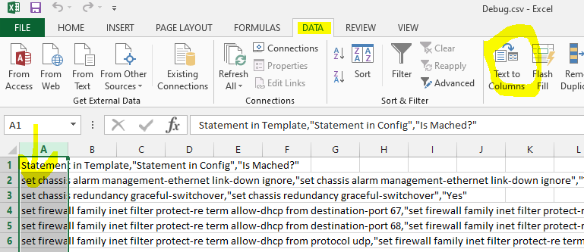

* + In “Convert Text to Column Wizard – Step 1 of 3”, select “Delimited” and click “Next”

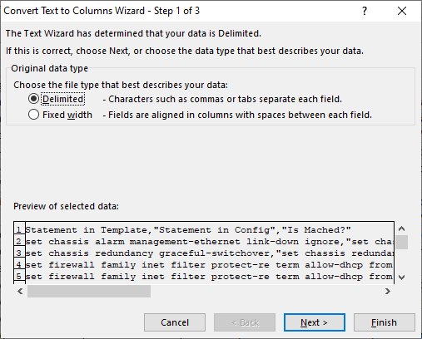

* + In “Convert Text to Column Wizard – Step 2 of 3”, under “Delimiters” check “Comma” and uncheck all others. Uncheck “Treat consecutive delimiters as one”. Select double quote (“) as “Text qualifier”. Click next

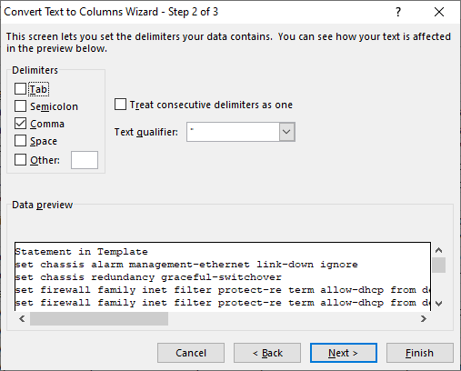

* + In “Convert Text to Column Wizard – Step 3 of 3”, in data preview window select each column and under “Column data format” select “Text”. Click “Finish”

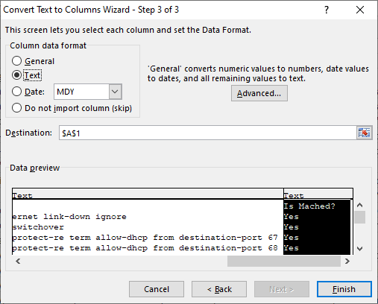

## How to save CSV file using Microsoft Excel

When saving a workbook as CSV using Excel only the working sheet of the workbook (the sheet open and visible) is saved. To save the sheet follow the instructions below.

* Make sure the sheet that you wish to save as CSV is in front and visible
* Select “File” menu and click “Save as”

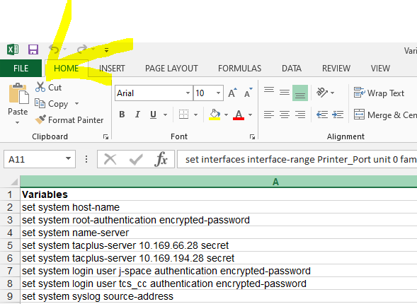

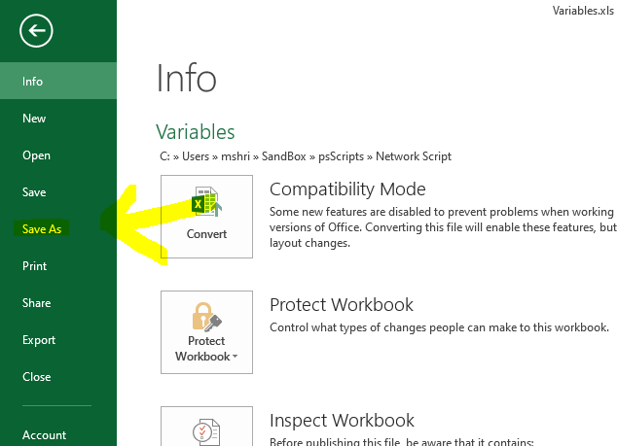

* Select the location where you wish to save the file
* In “File name” box, give the name you wish to give. (Do not put “.csv” at the end of file name)
* From the “Save a type” dropdown box, select “CSV (MS-DOS) (*.csv)”
* Click “Save”

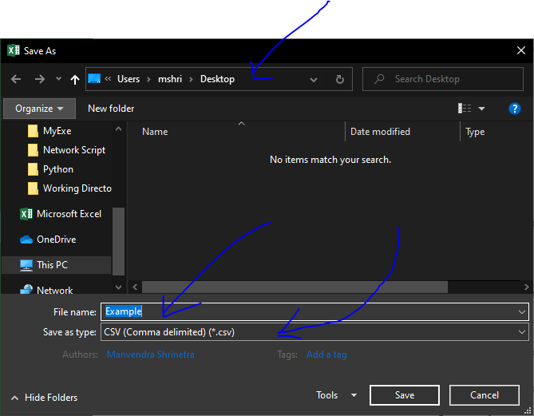

* A warning box will appear asking “Do you want to keep using that format?”, click “Yes”

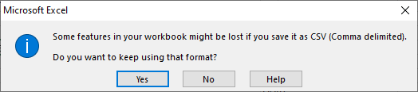

* Your file will be saved as CSV

# Instructions for the Script

## Starting Powershell to execute the script

This is common process to start powershell console to execute any script. See below instructions to execute the script.

**NOTE:** Always do the presetups required for a particular process (given in below script execution instructions for each process), before starting the powershell.

* Open powershell from start menu

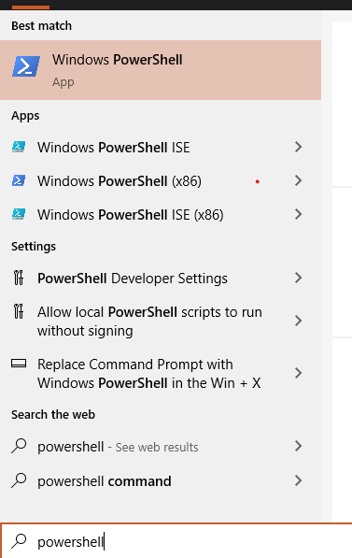

* Run following command, and upon prompt press “y” and enter.

Set-ExecutionPolicy -Scope CurrentUser -ExecutionPolicy Unrestricted

**NOTE:** Above command is executed to allow execution of script in current user scope, but depending upon environment policies, it may or may not be already allowed. If there is any problem, contact system administrator.

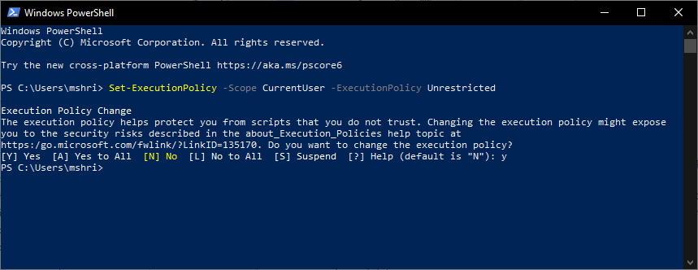

## Executing the script

### For validation

#### Pre-setups

* Create a folder, let’s say “Working Directory”
* Put template text file “template.txt” in it
* Create a master CSV (Comma Separated Value) file and name it “master.csv” and put in the folder.
  + Master file would contain three or more columns, with heading “Statement”, “Variable” and rest of the columns will have device name as heading.
  + In “Statement” column, there will be statements as it is there in the “templates.txt”
  + In “Variable” column, there will be variable part of the statement, that will change from configuration to configuration.
  + In columns with heading device name as heading, there will be values for that device for respective variable

**NOTE:** In “template.txt” there are some statements, in which there is no variable but some example value, in that case this example value should be there in the “Variable” column.

Below is an example screenshot of Master file.

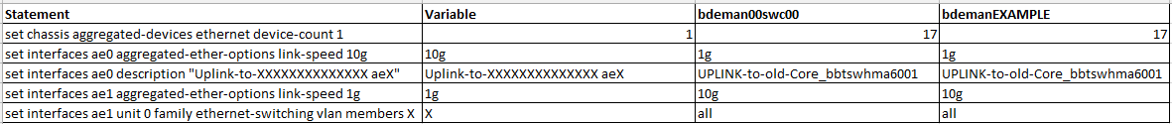

Collect all the configuration file of all the devices and keep it in the folder. Name each file as the device name. e.g. configuration file of device “bdeman00swc00” will be “bdeman00swc00.txt”

#### Executing the process

* Navigate to the location of script, e.g. if it is in “Network Script” Folder, run following command

cd "C:\Users\mshri\Network Script"

* Enter following command to start the script

.\WorkWith-TemplateAndConfig.ps1

* When prompted enter 1
* It will show “Validation Process” as selected.
* When prompted, enter the full path of the directory created in presetups
* Script will start and will show the progress
* Check the location of reports directory
* Separate report for each configuration file will be saved in report directory
* Upon competition when prompted press enter

Below is the sample screenshot:

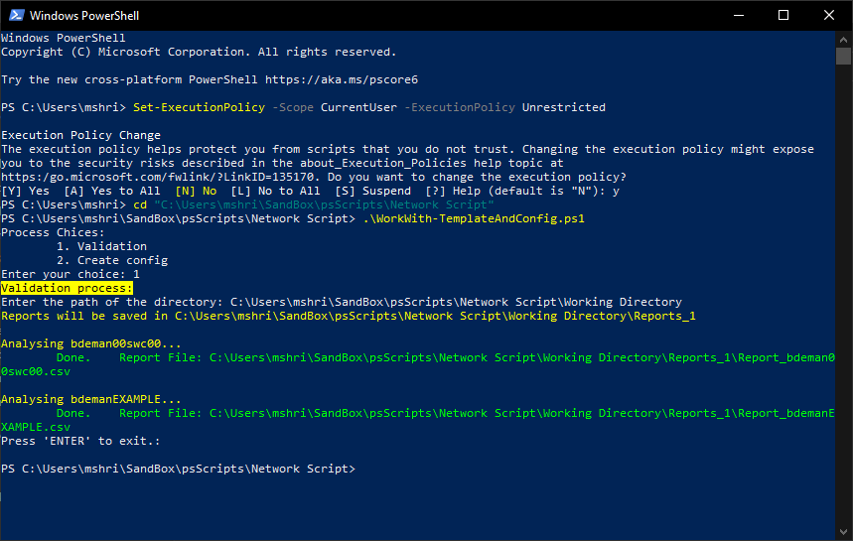

#### Checking Report

* Every time script is run, a new report directory is created
* In this directory report for each configuration is saved
* Reports are saved in CSV format
* Reports contains three columns, “Statement In Template”, “Statement in Config” and “Is Matched?”
* “Statemenmt In Template” is compared with “Statement in Config” with help from “master.csv” file.
* “Is Matched?” contains “Yes”, “No” or “Extra” based on if it is matched with template or not or it is extra statement in configuration file.

Below is a sample report screenshot:

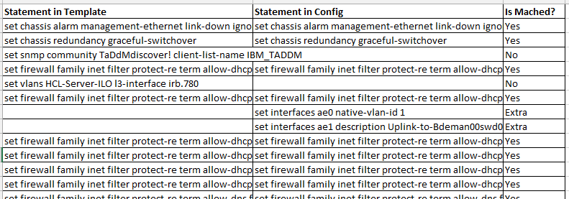

### For creating configuration files

#### Pre-setups

* Create a folder, let’s say “Working Directory”
* Put template text file “template.txt” in it
* Create a master CSV (Comma Separated Value) file and name it “master.csv” and put in the folder.
  + Master file would contain three or more columns, with heading “Statement”, “Variable” and rest of the columns will have device name as heading.
  + In “Statement” column, there will be statements as it is there in the “templates.txt”
  + In “Variable” column, there will be variable part of the statement, that will change from configuration to configuration.
  + In columns with heading device name as heading, there will be values for that device for respective variable

**NOTE:** If there is no value for a device in certain row, than that statement will not be added to the configuration file.

**NOTE:** In “template.txt” there are some statements, in which there is no variable but some example value, in that case this example value should be there in the “Variable” column.

Below is an example screenshot of Master file.



Collect all the configuration file of all the devices and keep it in the folder. Name each file as the device name. e.g. configuration file of device “bdeman00swc00” will be “bdeman00swc00.txt”

#### Executing the process

* Navigate to the location of script, e.g. if it is in “Network Script” Folder, run following command

cd "C:\Users\mshri\Network Script"

* Enter following command to start the script

.\WorkWith-TemplateAndConfig.ps1

* When prompted enter 2
* It will show “Config file creation process” as selected.
* When prompted, enter the full path of the directory created in presetups
* When prompted enter the name of devices separated by comma, if you wish to create for all the devices in the master file enter “all”.
* Script will start and will show the progress
* Check the location of reports directory
* Separate configuration file for each device will be saved in report directory
* Upon competition when prompted press enter

Below is the sample screenshot: 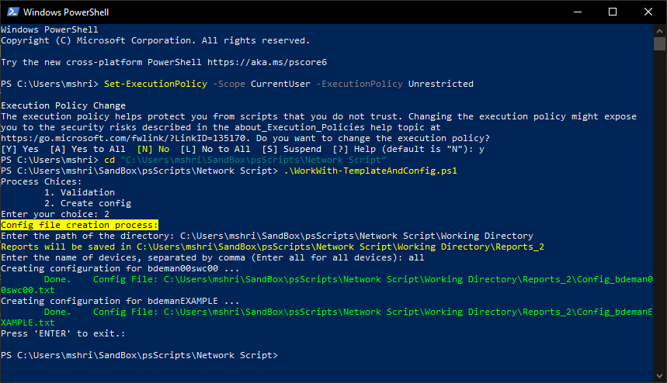

#### Checking Report

* Everytime script is run, a new report directory is created
* In this directory configuration for each device is saved
* Reports are saved as text files

Below is a sample report screenshot:

